**2 Problem Definition and Design Thinking**

**2.1 EMPATHY**

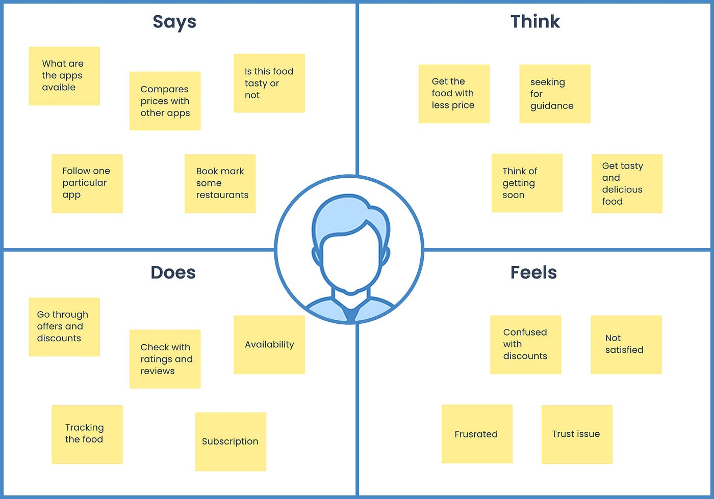

**2.2 IDEATION AND BRAINSTROMING MAP**

